Wellness Solutions for Optimised Performance
We're here to give your hard-working employees a chance to dive into the incredible benefits of Reiki sessions, right in the midst of their hectic schedules. Imagine…personalized sessions brought straight to your office, fitting snugly into cozy spots like spare rooms or conference rooms. And if that doesn't work, you’d be warmly welcomed at our Henrys Orchard treatment facility (10 mins from Junction 30 M1). Our individual on-site sessions are designed to seamlessly slip into employee break times, leaving them feeling refreshed, balanced, and totally ready to tackle their workload.
Feeling stressed or overwhelmed? Reiki's like a superpower for relaxation, zapping away stress and leaving you with that inner zen vibe. By bringing Reiki to your team, your company's giving them a powerful tool to effectively reduce stress and find some mental clarity, boosting emotional resilience and well-being along the way.
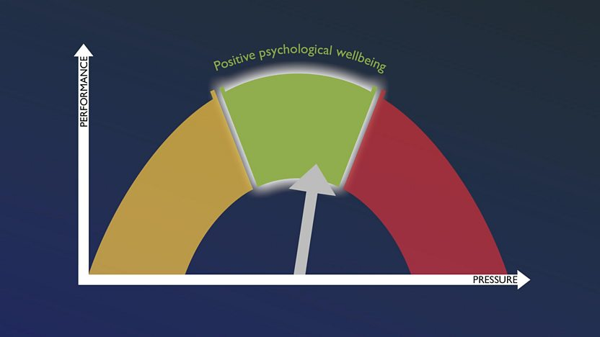
As we all know “HAPPY” employees are productive employees! When you invest in your team's physical and emotional health, you're setting the stage for fundamental job satisfaction. It's a win-win situation that can lead to happier employees who stick around for the long haul, creating a workplace where everyone thrives.
Worried about those healthcare costs? Integrating Reiki into your wellness program might just be the answer. By tackling stress head-on, you're potentially dodging those expensive bills related to stress-related illnesses and mental health issues. It's like a proactive approach to keeping your workforce healthy and thriving.
By showing your team some love with Reiki, your company's reputation gets a major boost. You become known as the go-to employer who cares about the whole package – not just the work stuff. Plus, it's a cool way to flex your corporate social responsibility muscles, showing the world that you're serious about taking care of your people.
Several organizations have recognized the benefits of Reiki and have integrated it into their workplace wellness programs. Here are some examples:
- Google: Google is known for its comprehensive employee wellness programs, which include various holistic health practices. The company offers on-site Reiki sessions as part of its wellness initiatives to help employees manage stress, improve focus, and enhance overall well-being.
- Nike: Nike prioritizes employee wellness and offers a range of holistic health services, including Reiki, to support their employees' physical, mental, and emotional health. Reiki sessions are available to employees as part of Nike's wellness program, helping them recharge and rejuvenate during busy workdays.
- Apple: Apple is committed to creating a positive and supportive work environment for its employees. As part of its wellness offerings, Apple provides access to Reiki sessions to help employees relax, reduce stress, and maintain a healthy work-life balance.
- Intel: Intel recognizes the importance of employee well-being and offers a variety of wellness programs to support its workforce. Reiki is among the holistic health services available to Intel employees, providing them with an opportunity to recharge and improve their overall health and wellness.
- Cisco: Cisco places a strong emphasis on employee wellness and offers a range of wellness programs to support its employees' physical and mental health. Reiki is integrated into Cisco's wellness initiatives, allowing employees to experience the benefits of this healing practice in the workplace.
These examples demonstrate that organizations across various industries recognize the value of integrating Reiki into their workplace wellness programs to support employee health, well-being, and productivity. By offering Reiki sessions as part of their wellness initiatives, these companies create environments where employees can thrive both personally and professionally. Whilst these are predominantly global multinational organizations, Reiki is now more accessible and affordable than ever, catering to businesses of all sizes and individuals alike through partners like Sycamoreiki.

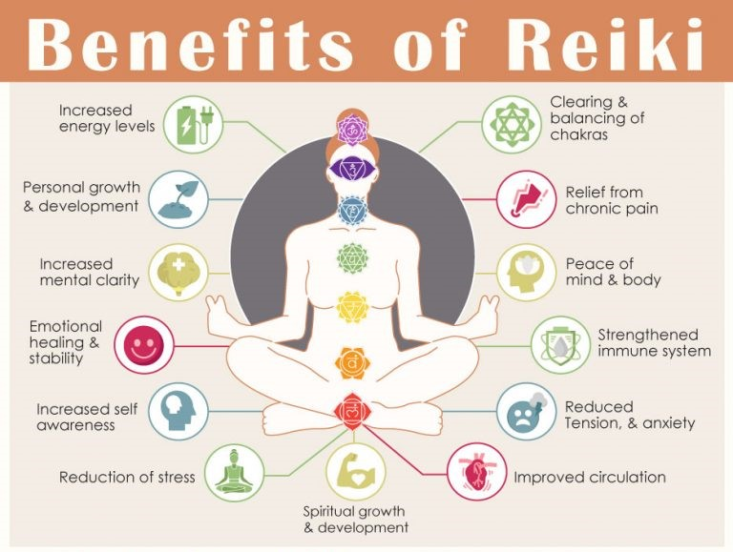
So, Reiki isn't just some fluffy wellness trend – it's a game-changer for your company. Whether you're weaving it into your next corporate event or making it a regular part of your wellness program, Reiki is like a secret weapon for boosting energy and showing your team some serious appreciation. Get ready to watch your workplace transform into a hub of vitality and gratitude!
Here are Sycamoreiki’s foundational well-being initiatives that we can customize to meet your organization's specific needs:

Motivation Monday | Kickstart the week with motivation and energy
Transformation Tuesday | Focus on personal growth, development, or positive changes
Wellness Wednesday | Align with the midweek point, offering a boost of wellness-related activities, initiatives, or discussions to help employees stay healthy, motivated, and engaged throughout the week
Therapeutic Thursday | Focused on relaxation, self-care, and therapeutic activities to help employees unwind and recharge as the week progresses
Feel Good Friday | Dedicated to experiencing the rejuvenating and revitalizing effects of Reiki. It could involve offering Reiki sessions to employees to help them recharge and renew their energy before the weekend, promoting relaxation, balance, and overall well-being
Contact Us to arrange a FREE trial today!
Hello@sycamoreiki.com

